Please supply one order form per person

Name:
Scout Group:

Email:
Cell number:

Pick up at National Scout shop. Yes/No
Delivery (postage R90)
To be delivered to: (Address)
__________________________________________________________________________
__________________________________________________________________________

Please indicate your preferred size in the table below: XS, S, M, L, XL, 2XL, etc.

Quantity | Size | Male | Female | Description | Unit Price  incl. VAT | Total  incl. VAT
 |  |  |  | SCOUTS SA branded cycling shirt | R650
 |  |  |  | WOSM & SCOUTS SA branded cycling shirt (royalty fee incl.) | R850
 |  |  |  | Purple / black cycling pants/bib | R750
 |  |  |  | SCOUTS SA branded kit (shirt & bib) | R1250
 |  |  |  | WOSM & SCOUTS SA branded kit (shirt & bib – royalty fee incl.) | R1450
 |  |  |  | Postage | R90
Total (incl. VAT)
The processing of your order is subject to SCOUTS SA receiving payment for the order. Minimum order per design is 10. All complete orders will be placed on the 3rd February 2020.
Lead time is 4 weeks so final deadline for this round of orders and payments is 31 January 2020.
Next order deadline April 2020.

Signed: _____________________________ Date: ______________________

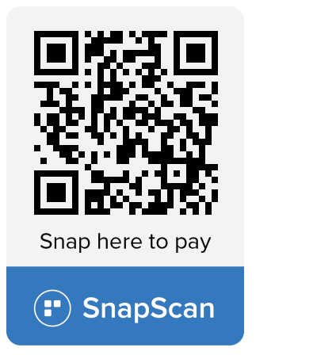
Bank detail:
Nedbank
Account number: 1083278509
Reference: “Cycle + Surname”
Account name: SCOUTS South Africa
Branch code: 108309

